**GIT LAB ASSIGNMENT -1**

NAME: AGILAMBAL S

ROLL NO:731621121003

E-MAIL ID:agilambal5s@gmail.com

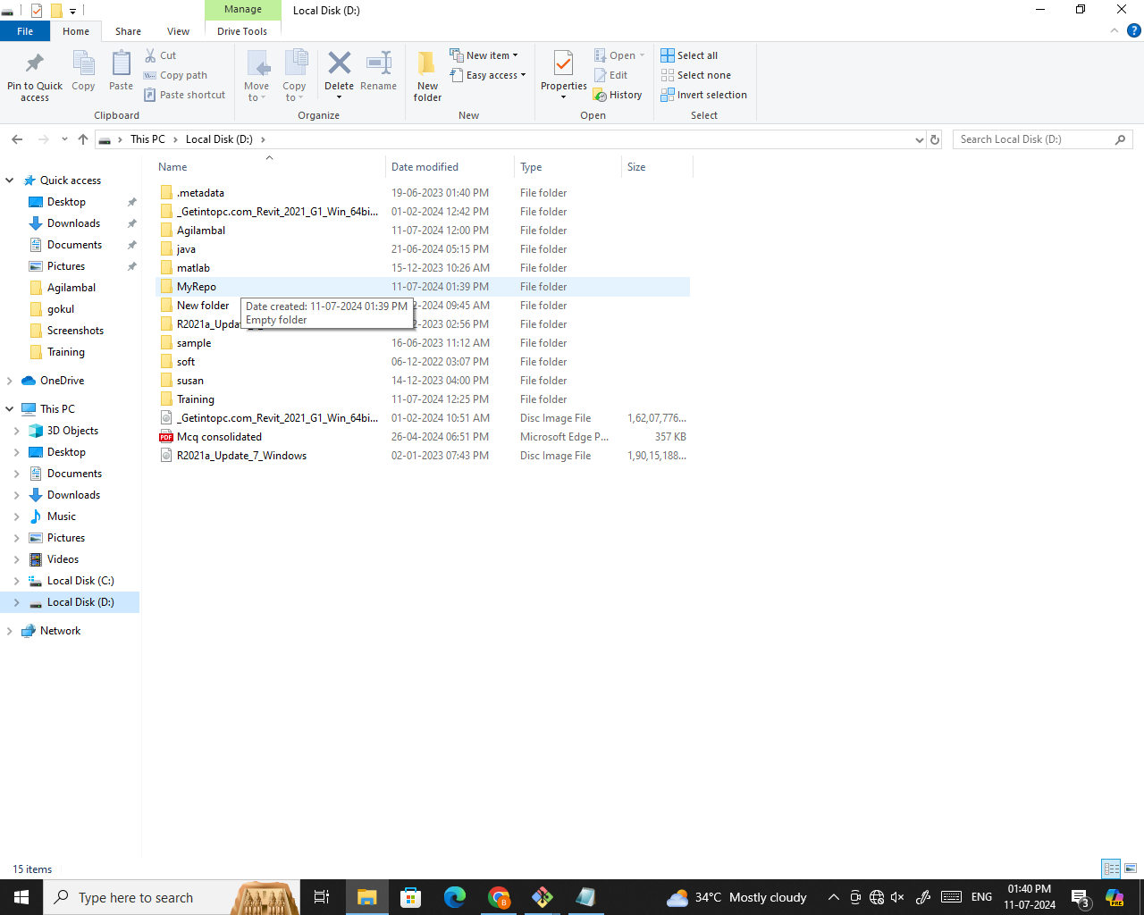**1.Create a local git repo with the name "MyRepo".**

**2. create one .txt file, five .c files and five .java files in the working area.**

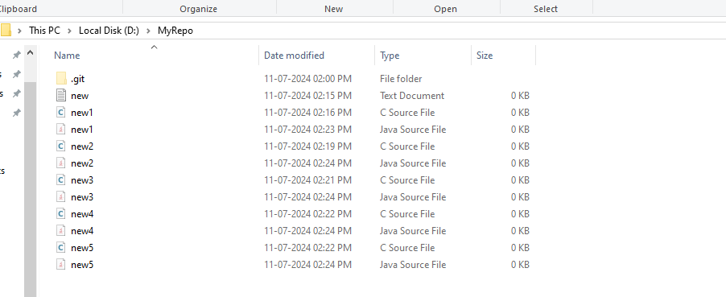

**3. Verify the git status**

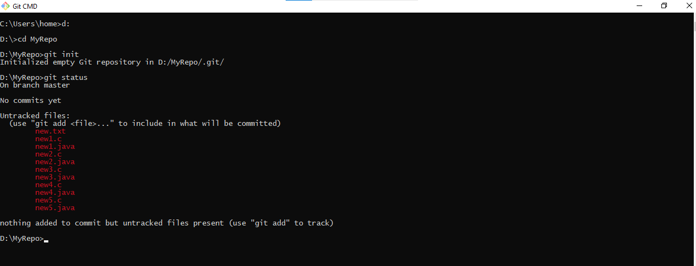

**4. Add only the .txt into the staging area**

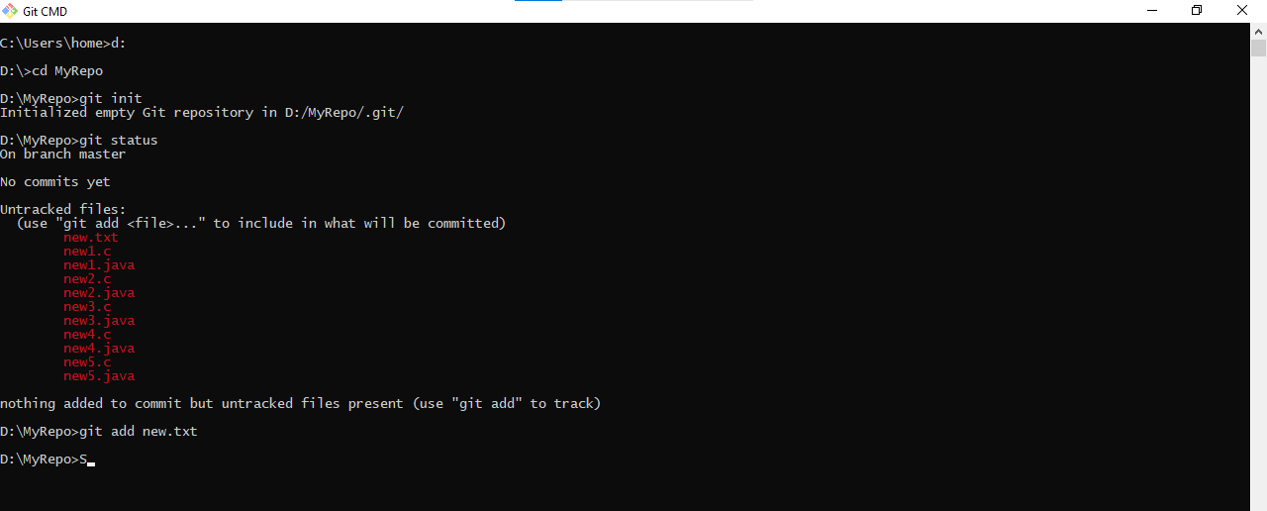

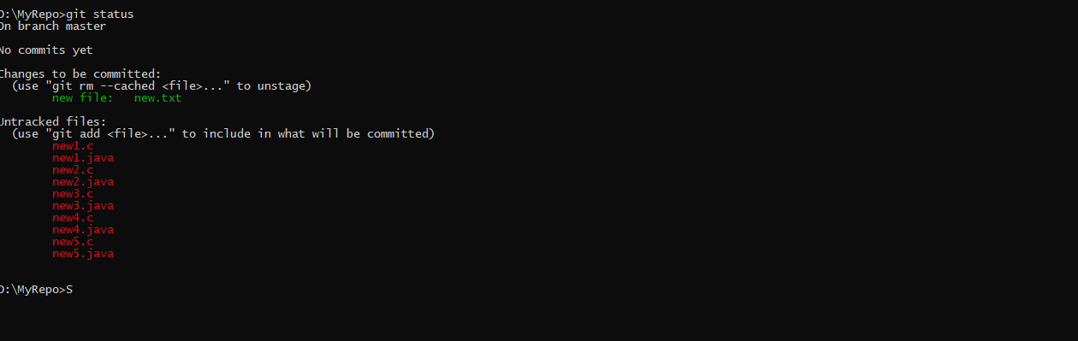**5. verify the git status**

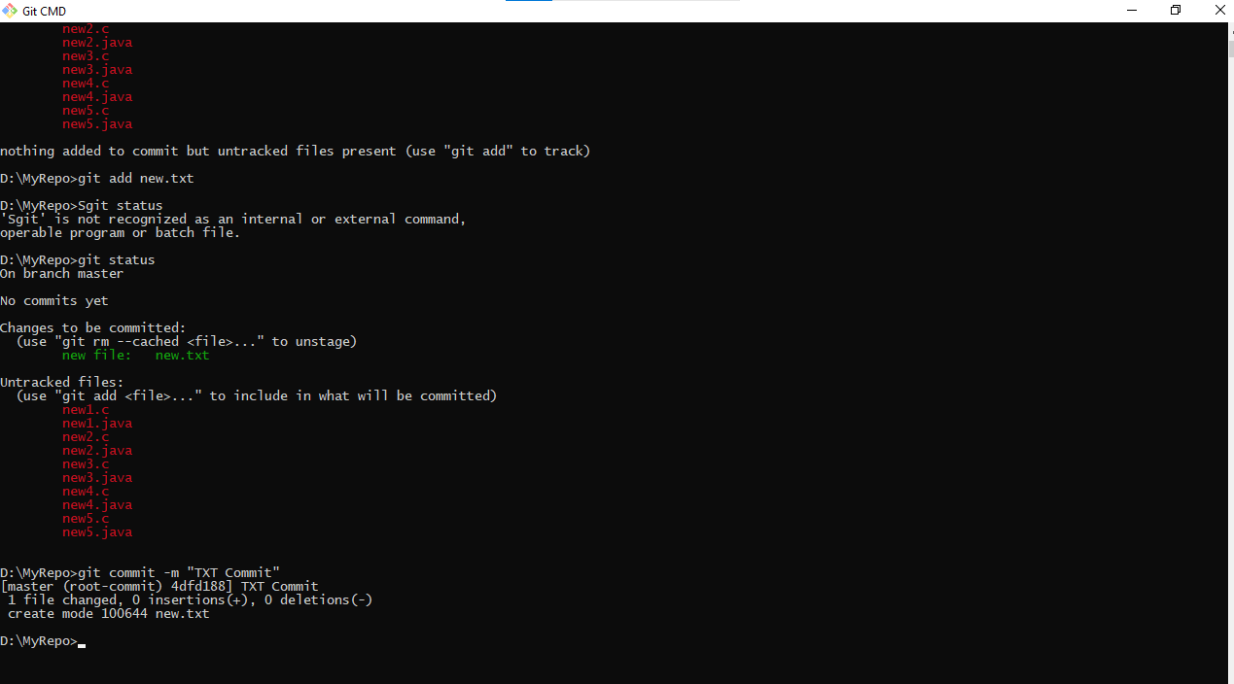**6. Make a commit with the name "TXT Commit"**

**7. Add all .c files into the staging area**

**8. verify the git status**

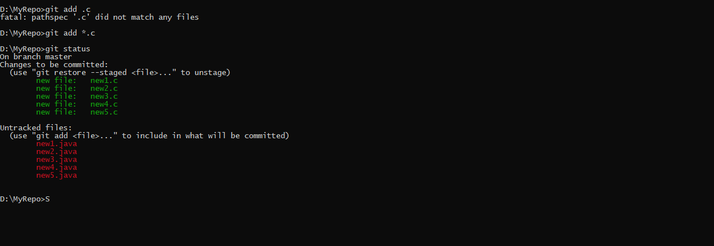

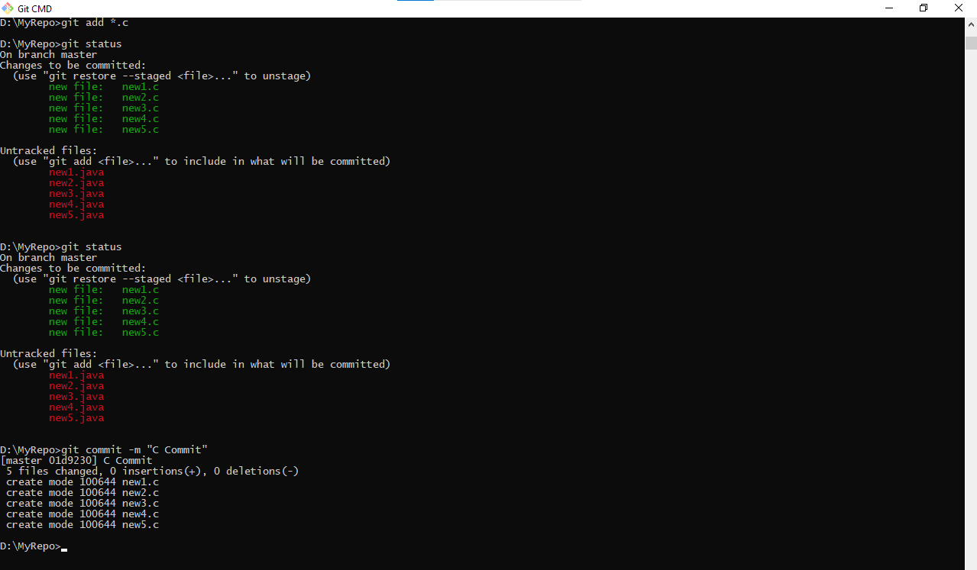**9. Make a commit with the name "C Commit"**

**10 .Add all .java files into the staging area**

**11. verify the git status**

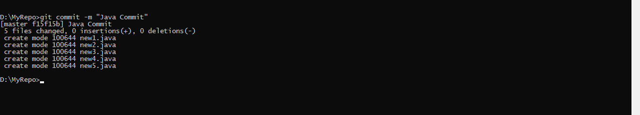**12. Make a commit with the name "Java Commit"**

**13. Delete all .java files from working area.**

**14. Now see the status**

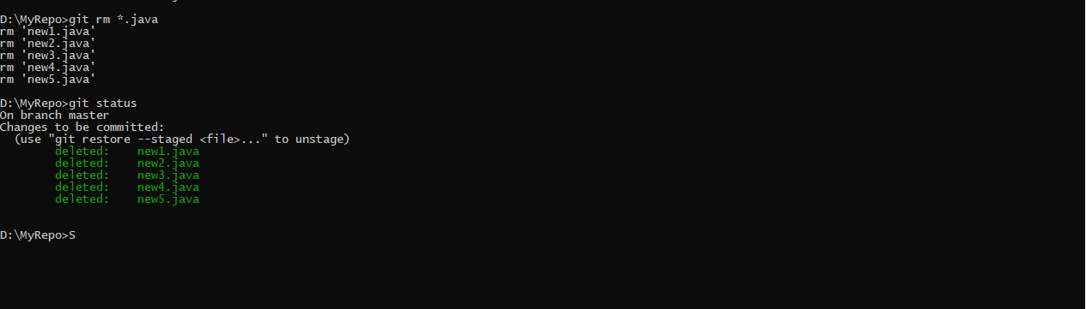

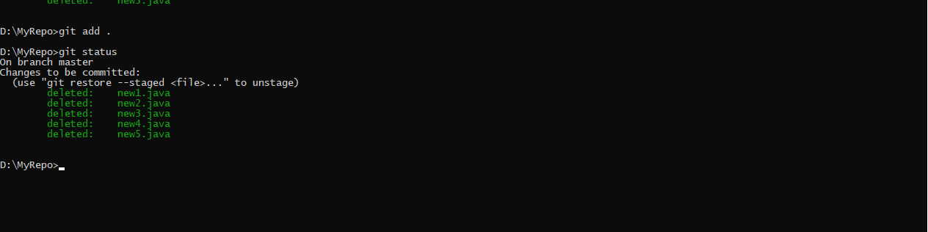**15.Add the changes into the Staging area**

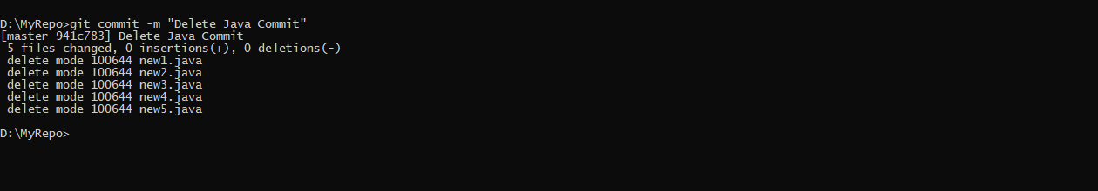**16.Make a Commit with the name” Delete Java Commit”**

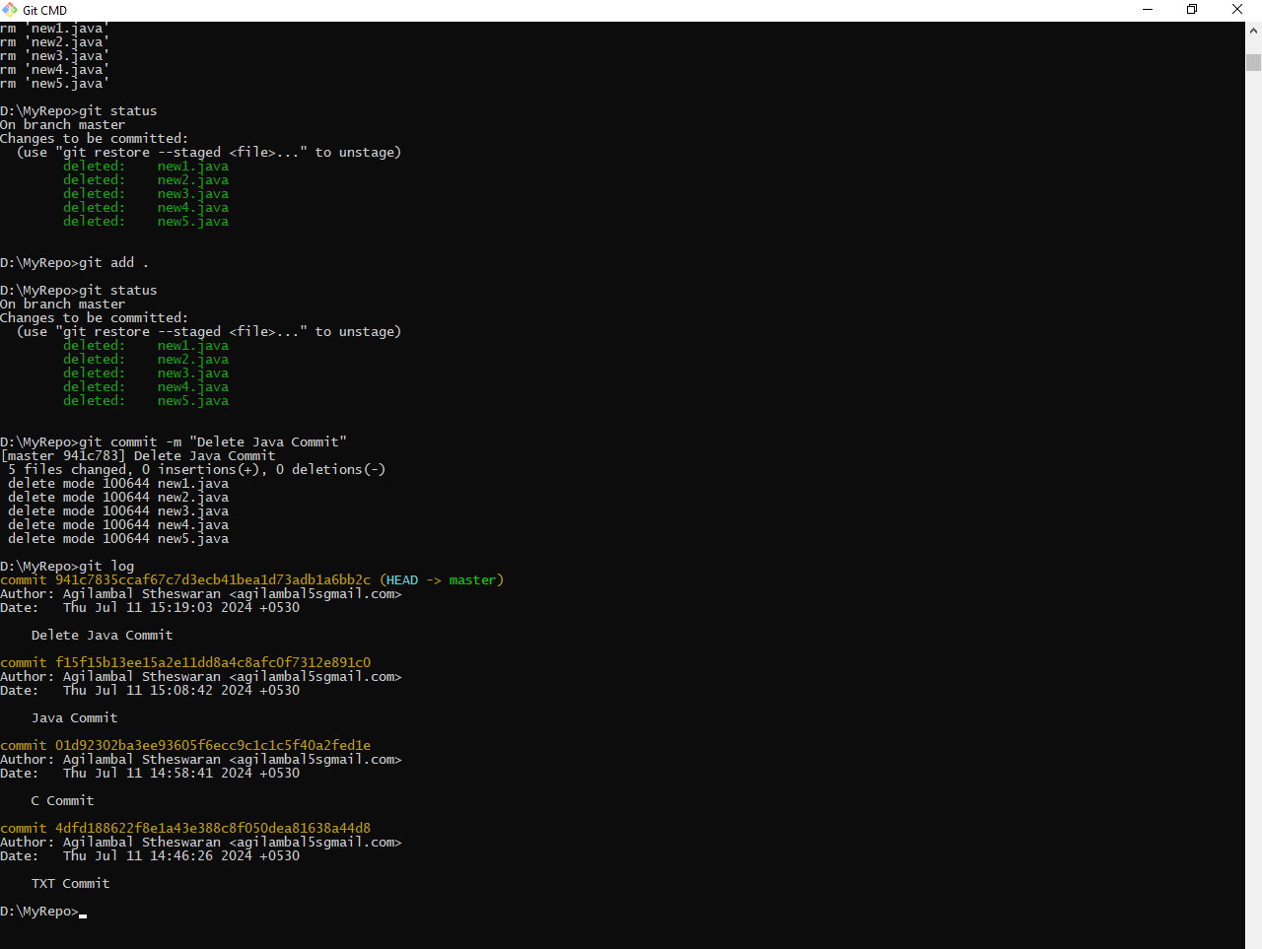**17.Display all commit details**